**Tradeoff-mediated Drought Legacy in Soil Microbiome**

# **Abstract**

The irreplaceable, profound role of soil microbiome in completing biogeochemical cycling in the Earth System makes fully understanding its response to drought of increasing frequency and severity pivotal toward evaluating drought-mediated biosphere-atmosphere interactions. Though with over a-half century of extensive research on drought impacts on soil microbiomes, drought legacy, a phenomenon of persistence of past effects that has been widely discussed in soil microbiome (and broadly across natural systems) and may largely influence microbiome and ecosystem functioning, is still with a yet unresolved mechanism. Here, using a trait-based microbial systems modelling framework with an explicit intra-cellular metabolic allocation of enzyme, osmolyte, and yield, we revealed a range of drought legacy scenarios from persistent through transient to no legacy depending on drought intensity and microbial dispersal. These trait-based findings point to a more fundamental physiological tradeoff-based and community position-determined mechanism. This mechanism indicates that any factor that can influence the physiological tradeoff between resource acquisition (i.e., enzymes) and stress tolerance (e.g., osmolytes) and change the trajectory of a community on the enzyme investment-drought tolerance-yield constrained space would alter the property of drought legacy. These mechanistic insights into historical contingency of soil microbiome functioning hold tremendous promise to quantifying and predicting soil microbiome functioning more accurately. This study inspires us to couple microbiome with vegetation with a holistic ecosystem view by capturing major tradeoff dimensions to evaluate and predict drought-biosphere interactions.

**1 Introduction**

Drought of increasing severity and frequency both regionally and worldwide (**~~Borsa et al. 2014;~~ Park Williams et al. 2020**) is one of the most pressing problems to the biosphere in general and to, specifically, microbiome in terrestrial ecosystems (**Berdugo et al. 2020**). The unparalleled role of soil microbiome in driving materials’ cycling in the Earth system (**Falkowski et al. 2018**) makes understanding its response to drought integral for systematically evaluating drought impacts on the biosphere, which, however, is still largely missing or implicitly treated in global assessments of drought-biosphere interactions (e.g., **Green et al. 2019**). Over a-half century of research has uncovered physio-chemical, physiological, and ecological mechanisms explaining immediate impacts of drought disturbance on microbial systems functioning in soil environment (e.g., **Birch 1958, Schimel 2007; Manzoni et al. 2012**). However, persistence of drought effects in soil microbiome (e.g., **Evans and Wallenstein** **2012**; **Meisner et al. 2015**; **Hawkes et al. 2017; Hinojosa et al. 2019; Glassman et al. 2019**), a phenomenon termed drought legacy (or memory of drought) that has also been widely observed across the forest biome (e.g., **Anderegg et al. 2015; Johnstone et al. 2016; Conradi et al. 2020**), still intrigues researchers for mechanistic explorations. Elucidating the processes leading to drought legacy in organic matter decomposition is undoubtedly not only essential for understanding microbial systems resilience but also for completely quantifying responses and feedbacks of whole ecosystems to drought in the Earth System.

Past lab- and field-based efforts on soil microbiome drought legacy proposed to explain legacy by depicting compositional differences in terms of a few functional types. Notably, **Hawkes and Keitt (2015)** proposed a mechanism of community-level shift in relative abundance of moisture generalist vs. specialist, of which generalist is functionally more stable than specialists with moisture. This idea was argued to explain the observation of a lack of change in moisture response across sites in Texas, USA because of observed dominance by generalist taxa resulting from high variation in historical rainfall (**Hawkes et al. 2017; Waring and Hawkes 2018**). Similarly, **Evans and Wallenstein** (**2014**) argued from the point of view of discrete life strategy to explain soils with relatively stable moisture history had more moisture-sensitive taxa and hence larger changes in biomass and composition (**Evans and Wallenstein** **2012**). These proposed explanations at the community level in terms of coarse, discrete functional groups, though intuitively appealing, cannot really tell how a community can be really shaped by past drought disturbance and how its functional change can persist to enable drought legacy. This deficiency becomes especially apparent when having many studies reporting legacies of varying magnitudes with differing time frames, especially those that even did not observe a drought legacy at all (e.g., **Rousk et al. 2013; Fuchslueger et al. 2016**). In fact, such a missing of mechanistic details also applies to warming-based historical contingency of microbial systems functioning (e.g., **Karhu et al. 2014**). We need a more fundamental mechanistic explanation that can link individual-level mechanistic details to community-level interactions to explain persistence of microbial systems functioning. Moreover, in a field manipulative experiment of rainfall and nitrogen conducted at Loma Ridge, Southern California, **Martiny et al. (2017)** measured drought legacy attributed to bacterial composition change with an alteration of carbohydrate degradation traits but not for nitrogen addition that instead did not present a change in carbohydrate degradation traits. This clear contrast further motivates us to find a trait-based linkage between organismal physiology and community shift underlying legacy.

Trait-based insights can bridge the gap between individual physiology and community-level dynamics, which are expected to explain the drought legacy phenomenon. Physiologically, it is well established that a microbial cell can direct available resources from producing exoenzymes to acquire resources to produce, e.g., osmolytes, to combat desiccation (e.g., **Schimel 2007**), an intra-cellular metabolic plasticity responding to fluctuating environment that displays large inter-cellular variability (e.g., **Manzoni et al. 2012**). Quantifying the individual-level metabolic variation in these processes using physiological traits that reflect and determine demographic variation among individuals, a trait-based mechanistic framework, Y-A-S (Yield-Acquisition-Stress), has been proposed (**Malik et al. 2019**). Therefore, in response to drought pressure physiological adaptation and turnover of individuals comprising a microbial community would drive community-level changes against the need to increase its community-level drought tolerance. Unambiguously, a drought legacy of changing organic matter decomposition can be induced only by persistence of the functional change of a microbial community; a legacy may occur if an emergent community trade off its increased drought tolerance with decreased enzyme investment. With this reasoning any factor that can eventually modify such a tradeoff from the bottom up may alter the property, magnitude, and duration of drought legacies. For instance, the intensity of drought, which directly modulates intracellular metabolic allocation (**Csonka 1989; Schimel 2007**), may shape the tradeoff. In addition, dispersal of microbes, a pivotal process in microbial community assembly by introducing taxa with different trait values (e.g., **Fukami 2015; Vila et al. 2019**;), is another factor that may alter drought legacy (**Hawkes et al. 2017**). To uncover this trait-based mechanism underpinning and factors influencing drought legacy in microbiome, it is methodologically intrinsic to employ a bottom-up approach that can integrate trait-based individual-level mechanistic details and community-level interactions into microbial systems functioning, which hinders lab- and field-based studies.

Instead, theory-driven trait-based modelling is well positioned to transcend limitations embedded in the current generation of lab- and field-based investigations. Individual-based microbial system modelling applying a trait-based approach is able to bridge across scales from individual cell through community to the system level to explicitly simulate ecological dynamics of microbial communities and emergent functioning. Such a modelling approach is superior to the prevailing aggregated modelling approach of treating microbes as a single biomass pool or a few discrete functional groups [a review by **Wieder et al. (2015**); **Hawkes and Keitt (2015)**]. It offers a flexible modelling framework allowing building trait-based intra-cellular metabolic processes into it and incorporating the tremendous taxonomic diversity, as well as examining microbial dispersal (**Allison 2012**). Moreover, conducting modelling of legacy can directly test the claim that including legacy would be trivial in biogeochemical modelling (**Rousk et al. 2013**).

Is the trait-based, tradeoff-mediated mechanism underpinning soil microbiome drought legacy? This study addressed this overarching question using a mechanistically and spatially explicit trait- and individual-based soil microbial systems modelling framework—DEMENTpy. Specifically, these following questions were answered: how does the magnitude of drought legacy effects on decomposition vary with drought intensity? How does dispersal of microbes affect the formation of drought legacy? And what are the underlying changes in traits of enzyme investment and drought tolerance? We tackled these questions by applying the DEMENTpy to a grassland ecosystem in Southern California. This study would open up rich possibilities for more quantitative investigations into trait-based rules of soil microbial community assembly and into implications of legacies in microbial systems interacting with vegetation activities for the biosphere-atmosphere interactions.

**2 Methods**

## **2.1 Model description**

DEMENTpy (DEcomposition Model of ENzymatic Traits in Python; GitHub Repository: <https://github.com/bioatmosphere/DEMENTpy>) is a spatially and mechanistically explicit trait- and individual-based microbial systems modelling framework built upon its predecessor DEMENT (**Allison 2012; Allison 2014; Allison and Goulden 2017; ~~Wang and Allison 2019~~**). This model randomly initializes a microbial community on a spatial grid based on physiological traits and simulates its dynamics by modelling explicitly demographic processes of each population including cell metabolism and growth, mortality, and reproduction at a daily time step. Driven by temperature and moisture, the community secretes different exoenzymes decomposing different organic compounds. Starting from continuous physiological traits, DEMENTpy bridges across scales from individual through community to systems in soil microbiome (see **Supporting Fig. 1** for model structure). Below only community initialization and intra-cellular metabolic allocation are highlighted. More details with respect to structure, processes, formula, and parameters are referred tothe **Supporting Information.**

With a trait-based approach, DEMENTpy creates a microbial community composed of a large number of hypothetical taxa by randomly drawing values from uniform distributions of microbial traits and assigning them to different taxa (see a list of traits in **Supporting Fig. 1B** and more details in **Supporting Text**). The traits include rates of enzyme production (constitutive and inducible) and rates of osmolyte production (constitutive and inducible). Drought tolerance of each taxon is determined by normalizing the inducible osmolyte rate of production to a value from 0 to 1. This formulation establishes a mechanistic connection between osmolyte production and drought tolerance (**Schimel 2007**) in contrast to the previous model version which instead directly introduced a drought tolerance parameter and imposed a penalty on carbon use efficiency accordingly (**Allison and Goulden 2017**).

DEMENTpy explicitly treats intra-cellular metabolism of ingested monomer carbon derived from explicit exoenzymatic degradation of substrates (see the **Supporting Text** for substrate degradation and other demographic processes). The metabolic processing of assimilated carbon after growth respiration is directed to produce enzyme (and respiration) and osmolyte (and respiration; **Csonka 1989; Witteveen and Visser 1995**), which are treated as simultaneous processes without prescribing an order (**Supporting Fig. 1C**). The carbon left after these processes accumulates toward biomass. We assume the constitutive osmolyte production rate varies across taxa without depending on water potential, accounting for bacterial/fungal cell’s allocation of biomass to keep a water potential balance across cell wall (**Csonka 1989**). By contrast, inducible production of osmolytes is subject to constraints from water potential only below a certain threshold. Arising from metabolic production of enzyme and osmolyte, mortality of microbial cells is simulated both deterministically by accounting for mass balance and stochastically based on death probability constrained by drought tolerance and water potential.

## **2.2 Modelling experiments**

We applied DEMENTpy to the grassland system at Loma Ridge, Southern California (**Allison et al. 2013**) and parameterized the model with 100 different hypothetical bacterial taxa on a 100 by 100 spatial grid decomposing grass litter containing ten different substrates (see parameter values in **Supporting Table 1** and substrates in **Supporting Table 2**). DEMENTpy was benchmarked with the daily weather data of year 2011, which is treated as the ambient scenario (**Supporting Fig. 2A**).

On top of this ambient scenario we conducted simulations with manipulated drought to examine drought legacies (**Supporting Fig. 2**). Two drought scenarios, moderate and severe, were created by reducing the water potential across only the dry season by a factor of four and ten, respectively. After the drought period, the ambient scenario was re-imposed to examine changes in microbial communities degrading substrates. One set of such simulations without dispersal is referred to as default mode. Another set in dispersal mode is set to further examine how dispersal affects drought response over time.

## **2.3 Simulation protocol and data analysis**

With the model setup as above, we conducted simulations following the protocol as follows (**Supporting Fig. 2**): each simulation was run for 10 years at a daily time step after establishing an initial microbial community on the spatial grid with homogeneously distributed substrates, and in each new year substrates, monomers, and enzymes were reinitialized uniformly to have the same configurations as the very first year except for the microbial community. For the default mode, microbial community on the spatial grid in each new year was randomly reinitialized based on frequency of each taxon on the grid in the last day of the previous year (**Supporting Fig. 2C**). In contrast, in the dispersal mode the frequency was based on cumulative biomass of each taxon across the previous whole year (**Supporting Fig. 2D**). These simulations were repeated for each scenario under the two modes (default and dispersal mode) for 40 times with 40 different seeds. This sample size was determined by a convergence analysis of DEMENTpy’s stochastic nature (**Supporting Fig. 3**).

All results presented in this work, unless indicated otherwise, were analyses of such an ensemble of 40 runs for each of the five scenarios (5×40 = 200 runs in total). A dataset was established from these simulations encompassing taxon traits (enzyme investment and drought tolerance), time-series of taxon-specific biomass, and time-series of community-level carbon allocation (enzymes, osmolytes, and yield), as well as time-series of compound-specific and total substrates. With taxon traits and biomass biomass-weighted community-level traits, enzyme investment and drought tolerance, were calculated (see the **Supporting Text** for calculation method). In addition, 95% confidence intervals were presented in most of the cases except for microbial community composition and community carbon allocation, for which results of only one out of the 40 simulations were shown.

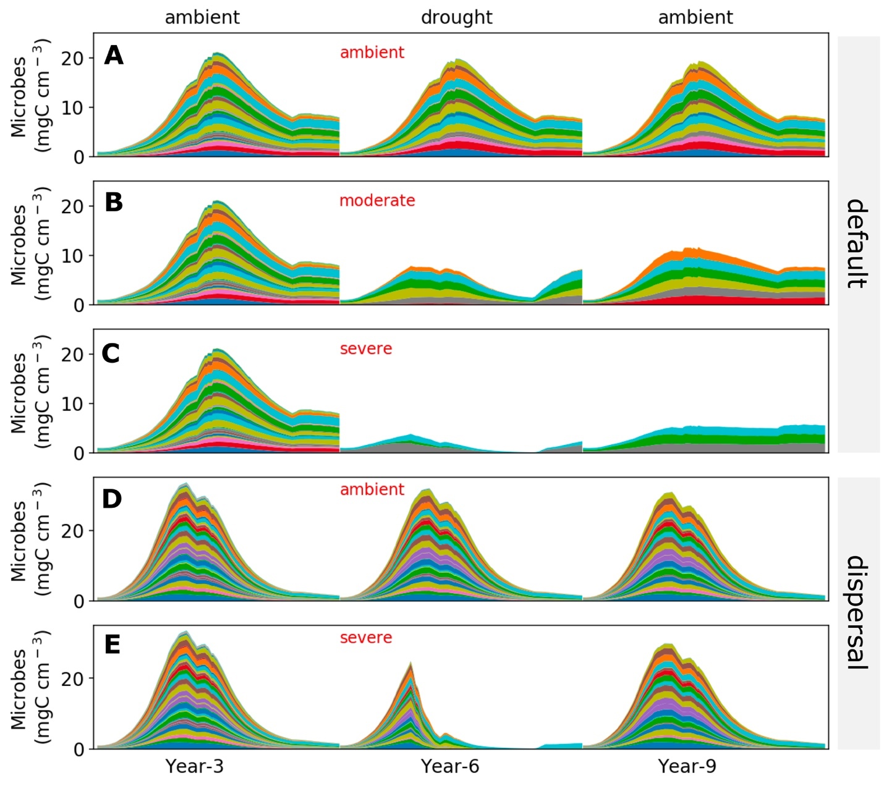

**Fig.1. Microbial community dynamics disturbed by drought of differing severities with and without dispersal.** (**A-C**) Dynamics without dispersal under ambient, moderate, and severe scenario, respectively. (**D, E**) Dynamics with dispersal under ambient and severe scenario, respectively. Colored bands represent different hypothetical taxa in terms of biomass (mg C cm-3) averaged over the 100×100 spatial grid. Data shown are only for years 3, 6 (the 3rd year under drought), and 9 (the 3rd year after drought). See **Supporting Fig. 2** for the full 10-year dynamics under the ambient scenario of both default and dispersal mode.

# **3 Results**

## **3.1 Microbial community dynamics under the ambient drought scenario**

The system became relatively stable after 2 years, with seasonal dynamics in the microbial community repeating across years (**Supporting Fig. 2**). Seasonal dynamics with respect to community composition and biomass reflected a joint control by environment and substrates. Starting from the wet season that was replete with substrates, a microbial community consisting of different taxa established and grew in biomass. As substrates were degraded and depleted, microbial cells began to starve and die. Increasing drought while entering the dry season induced more death. These two processes in combination resulted in the decline of microbial biomass after a biomass peak around 20 mg C cm-3 (**Fig. 1A)** and drove the composition toward taxa with higher drought tolerance and lower enzyme investment (**Supporting Fig. 4A**) and hence community level enzyme investment decrease (**Fig. 2A**) and drought tolerance increase across the dry season **Fig. 2B**). Similar seasonal and inter-annual dynamics were observed for the community with dispersal but with much higher biomass (peaked around 30 mg C cm-3) and taxonomic diversity (**Fig. 1D; Supporting Fig. 4B; Fig. 2C, D**).

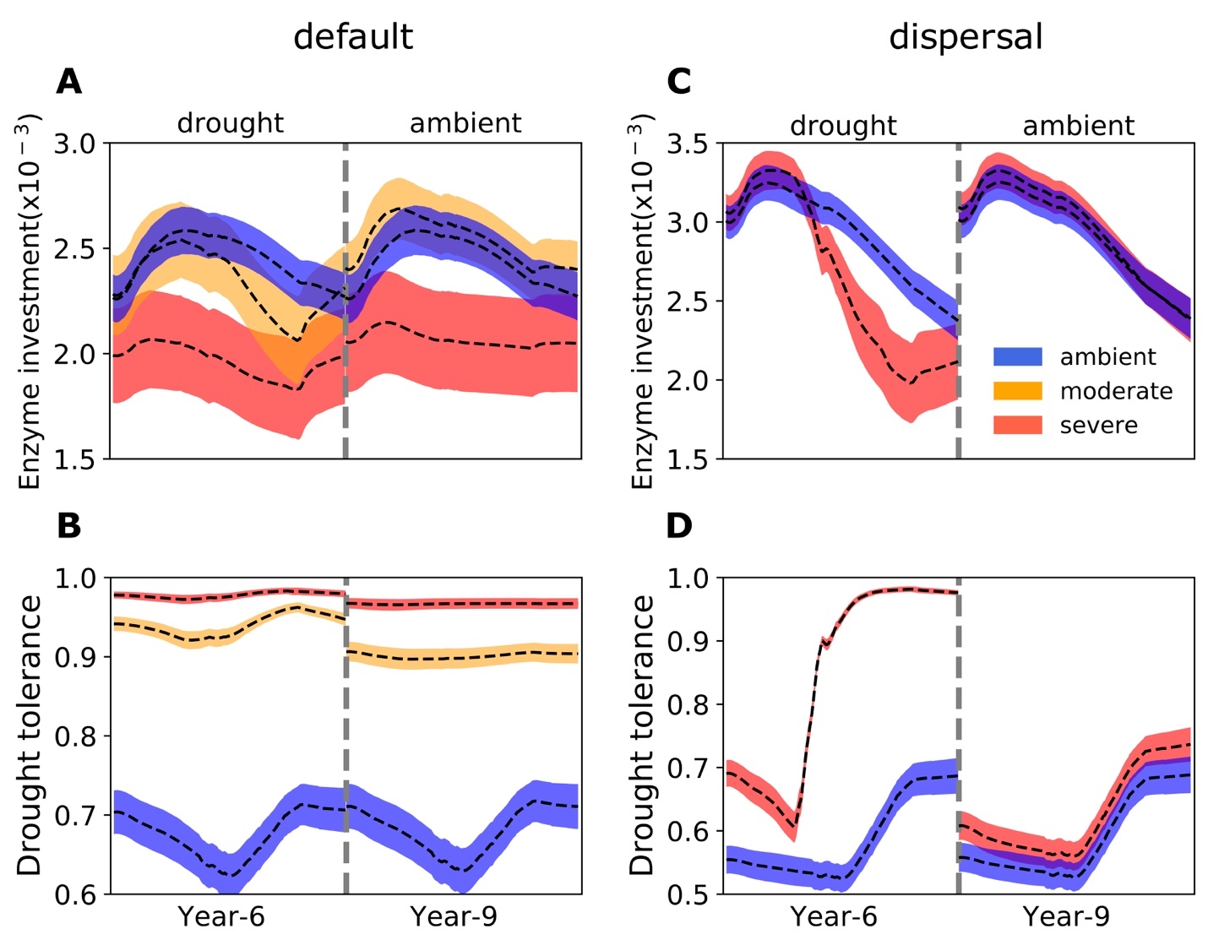

**Fig.2 Seasonal dynamics of community-level enzyme investment and drought tolerance of microbial communities under different drought scenarios.** (**A, B**) Enzyme investment and drought tolerance during year 6 (3rd year under drought) and year 9 (3rd year after drought) under three scenarios (ambient, moderate, and severe) without dispersal, respectively. (**C, D**) The same for communities with dispersal under two scenarios (ambient and severe).Dashed lines and color bands are means and confidence intervals (95%) based on 40 runs of each of the 5 scenarios.

## **3.2 Responses to and recoveries from drought disturbance of varying severity**

Variation in drought severity altered the microbial community to varying extents (**Fig. 1B, C**). Total biomass declined significantly, with the severe scenario declining the most by about 50% to a peak less than 10 mg C cm-3. Composition of the communities changed dramatically in terms of taxonomic richness and abundance after 2 years of drought perturbation with differing levels of drought tolerance and enzyme investment. Compared to the ambient scenario, drought tolerance increased significantly across the whole season from as low as only 0.62 to 0.92 of the moderate scenario and to 0.97 of the severe (**Fig. 2A,B**). However, the community enzyme investment only declined significantly in the severe scenario across the dry season and did not change much in the moderate scenario on average besides the later stage in dry season (**Fig. 2A,B**). These trait changes dictated differences in community-level carbon allocation between enzymes and osmolytes and thus yield (**Fig. 3A**). Under the moderate scenario, the percentage of assimilated carbon allocated to osmolytes ranged between 65–85%, compared to the ambient range of 50–70%, whereas enzyme allocation was consistently lower (10% on average) than the ambient (20% on average). However, the resulting yield was basically similar, ranging between 0 - 30%, though a few points in the ambient were higher (reaching at most 40%) early in the drought season. Under the severe scenario, the percentage of osmolytes became even higher and enzymes even lower, and the community yield approached zero more often. Eventually, these differences in community resource allocation between osmolytes and enzymes were manifested in the dampened degradation of substrates over the grid, with the two drought scenarios resulting in different levels of decomposition declines (average of 57.39 and 85.65%, respectively; **Fig. 4A, B**).



**Fig. 3 Ternary plots of community-level allocation of assimilated carbon among enzymes, osmolytes, and yield over time under different drought scenarios. (A, B**) Enzyme-Osmolyte-Yield tradeoff of communities during year 6 (3rd year under drought) and year 9 (3rd year after drought), respectively, of the default mode (without dispersal). (**C, D**) The same for the dispersal mode. The Y, A, and S (based on the Y-A-S framework) labeled at corners correspond to yield, enzymes, and osmolytes, respectively. Besides the ambient cases in default and dispersal mode illustrating the whole season, moderate and severe scenarios were only shown during the dry season. See **Supporting Fig. 2C** for calculations of enzymes, osmolytes, and yield.

Once the ambient conditions were re-imposed, after 2 years (year 9) new stable microbial communities formed (**Fig. 1B, C** and **Supporting Fig. 2C**). Compared to the ambient scenario, these newly-formed communities had different drought tolerance and enzyme investment (**Fig. 2A, B**). Drought tolerance was significantly higher under both the moderate (0.90) and severe scenario (0.96) than under the ambient, though both became a little lower than the communities realized under drought disturbance. In contrast, enzyme investment under the moderate scenario became similar to the ambient community, with only the severe scenario community remaining significantly different. Only the severe community showed a clearly lower allocation to enzymes than the ambient community across the dry season (**Fig. 3B**). This loss of differences in enzyme investment in the moderate community eventually resulted in only the severe scenario displaying significantly reduced degradation compared to the ambient scenario (by 47.72% on average; **Fig. 4B**), although the magnitude of decline was dampened compared to the antecedent drought period because of the relief of drought pressure (**Fig. 4A**). It is noteworthy that prior to year 9, the degradation changes resulting from the transient communities (year 7) were significant for both drought scenarios (an average decline by 18.00 and 55.52%, respectively).

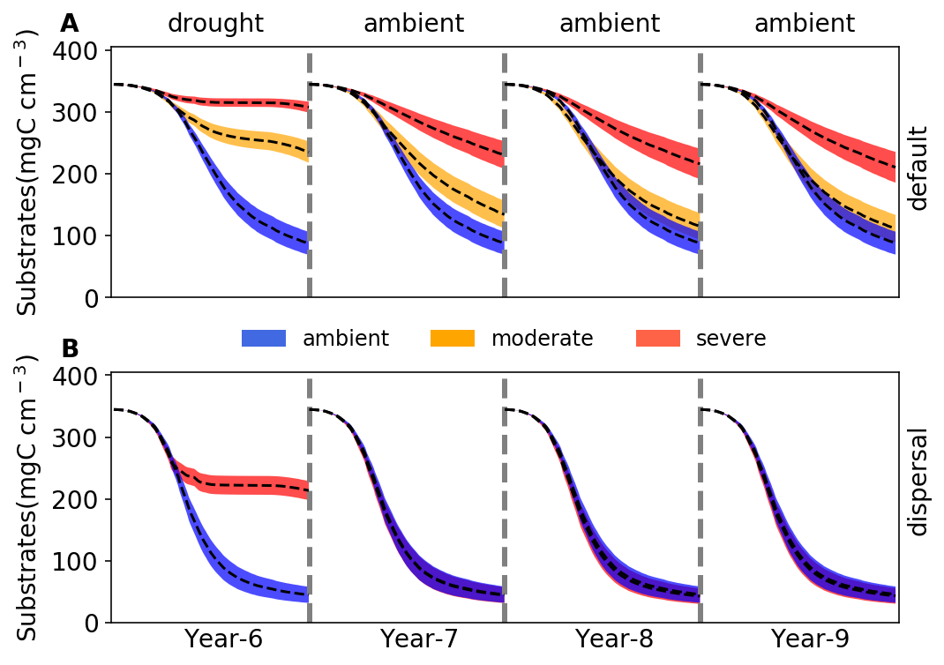

**Fig. 4 Changes in substrates driven by drought.** (**A**)Total substrates on the spatial grid over year 6-9 under three different scenarios (ambient, moderate, and severe) without dispersal. (**B**) The same for simulations with dispersal under ambient and severe scenarios. Dashed lines and colored bands are means and confidence intervals (95%), respectively, based on 40 runs for each of the five scenarios. See **Supporting Fig. 5** for an example illustration of the underlying substrate-specific changes.

## **3.3 Responses to and recoveries from the severe drought disturbance with dispersal**

With dispersal the microbial community realized under the severe scenario saw both lower total biomass and lower taxonomic abundance, particularly significant during the dry season (**Fig. 1E**). This stable community realized under severe drought had significantly different community enzyme investment and drought tolerance from the ambient. Enzyme investment declined from 0.0033 to 0.0020 and drought tolerance increased sharply from 0.60 to 0.97 across the dry season, increasing their differences from ambient over time (**Fig. 2C,D**). These changes resulted in the community allocating more assimilated carbon to produce osmolytes and less to enzymes, which resulted in zero yield when drought was most severe during the dry season (**Fig. 3C**). All these changes pointed to significant declines in decomposition of substrates (an average decline of 56.29%; **Fig. 4C**)

However, when ambient conditions were re-imposed, recovery from drought was rapid. After 2 years, the community became similar to the ambient (**Fig. 1E**). This compositional similarity coincided with similar community enzyme investment (**Fig. 2C**) and drought tolerance (**Fig. 2D**), which resulted in the same community-level allocation of assimilated carbon among enzymes (30 - 60%), osmolytes (40 - 60%), and thus yield (0 – 30%; **Fig. 3D**). These similarities eventually had the almost completely same substrates’ decomposition (**Fig. 4D**). In fact, in contrast to the default mode, the transient community did not show significant effects in the very 1st year after drought (year 7; **Fig. 4D**). This was attributed to the fact that the community became same immediately after the drought.

# **4 Discussion**

With trait-based modelling in a mechanistically explicit fashion, this study examined the relationships between drought legacy and drought severity and dispersal in simulated litter microbiomes. Manifestation of drought legacy at the system level in terms of litter decomposition was contingent on drought severity and microbial dispersal, forming an array from persistent through transient to no legacy at all (**Fig. 4**). Such a wide set of legacy scenarios with respect to property, magnitude, and duration point to a more overarching, fundamental mechanistic basis underpinning drought legacy in soil microbiome—physiological tradeoff between enzyme and drought tolerance.

Clearly, the severity of drought disturbance matters in the magnitude and duration of legacy formed via determining the extent to which a microbial community can adapt. By increasing the drought intensity we revealed legacies from transient to persistent (**Fig. 4A**). It is easy to expect no legacy at all if with an even weaker disturbance, which we did not cover in the current study. All these simulations were based on an assumption of a realization of stable state under drought disturbances. We argue this assumption is a reasonably good starting point, which in reality is not always the case for sure considering huge variation in frequency, intensity, and/or duration of drought.

Drought disturbance of a relatively low severity, though being able to result in a declined decomposition after disturbance conferred by the transient community, eventually saw a disappearance of the legacy effect (**Fig. 4A**), which we dub transient legacy. This transient legacy matches the field rainfall manipulative experiment with a reciprocal design at the same site very well, which observed mitigated drought legacy in terms of litter decomposition within three years (**Martiny et al. 2017**). It is noteworthy that this transient legacy arose from an eventual community with the same functioning but different composition and biomass. However, the role of biomass difference can be excluded for leading to this decomposition indifference, as indicated by the peak biomass decline by as high as 50% under the moderate scenario **(Fig. 1B**). This exclusion of biomass change in contributing to legacy formation is consistent with findings from both a field manipulative experiment at Loma Ridge, Southern California (**Martiny et al. 2017**) and a reciprocal transplant study across a climate gradient in Southern California (**Glassman et al. 2019)**. Therefore, the loss of legacy fundamentally resulted from the remaining same community enzyme investment (accompanied by a realization of higher community drought tolerance) after a relatively less intense drought disturbance (**Fig. 2A,B**). Such a compositional but not functional change in the new stable alternative system reflects a broad notion of functional similarity in the soil microbiome (**Allison and Martiny 2008**), which has been widely observed across natural systems (e.g., **Ives & Carpenter 2007;** **Fukami 2015**).

In contrast, persistent drought legacy (**Fig. 4B**) can be shaped by a stronger drought disturbance that can push the community to reach an even higher drought tolerance by sacrificing more of capability in enzyme investment, thereby forming a community not only compositionally but also functionally different (**Fig. 2A,B**). A similar long-term legacy but expressed in soil heterotrophic respiration was also observed by microcosm and field transplant experiments by **Hawkes et al. (2017)**. More generally, historical contingency of alternative stable system with a functional difference has been widely reported across different systems with disturbances beyond drought, e.g., in gut microbiota experiencing transient osmotic perturbation (**Tropini et al. 2018**) and in forest biome across tropical (**Hirota et al. 2011**; **Staver et al. 2011**) and boreal forest (**Herzschuh 2019**), as well as in small pond systems (**Chase 2003**).

However, microbial communities shaped by legacy of varying drought disturbance, though being able to last and carry the legacy effects into the future, are faced with other disturbances and thereby may be subject to changes. Our simulations demonstrated that dispersal is one such process that can negate formation of even transient legacy in organic matter decomposition. By constantly introducing taxa from the same microbial pool, we found that dispersal under even the severe drought scenario can completely mitigate the physiological tradeoff-mediated drought selection on a microbial community (**Fig. 1E**). As a result of community similarities in drought tolerance and enzyme investment (**Fig. 2C,D; Fig. 3D**), dispersal can overwhelm the drought legacy in organic matter decomposition (**Fig. 4B**). We must acknowledge that factors in dispersal influencing resident community are manifold (**Vila et al. 2019**); for instance, timing (i.e., priority effects; **Fukami 2015**) and velocity (**Evans et al. 2019**) both have been suggested to be important. Moreover, even an unsuccessful dispersal with only transient interactions can induce an alternative stable state functioning differently (**Amor et al. 2020**). Therefore, the scenario examined in this study (with a purpose of revealing underlying mechanisms) by no means is exclusive; for example, with passive dispersal in a field transplant experiment **Hawkes et al. (2017)** did not find any apparent mitigation of historical rainfall legacy in soil respiration. Therefore, responding to the huge variation in the dispersal process, a microbial community could instead present compositional and functional changes to varying extents (e.g., **Fukami 2015**) and hence varying magnitudes of legacy in decomposition, which warrant more explorations.



**Fig. 5 Drought legacy contingent on the trajectory of a microbial community on the Y-A-S space.** There will be no legacy if a community does not move at all or move along the thick black line. Instead, if the community moves into and stays in the grey region, persistent legacy will occur. However, if the community eventually leaves the grey region and settles on the thick black line, only transient legacy can occur. However, it is speculated to have another trajectory of a community moving into the red region with both increased drought tolerance and enzyme investment.

From the contrasts of cases of low vs. high drought severity (transient vs. persistent legacy) and of cases with vs. without dispersal (no legacy vs. persistent legacy), we can arguably deduce that drought legacy in microbiome functioning originates from physiological tradeoff between enzyme and osmolyte production and is eventually determined by the position that a community can reach on its potential space constrained by enzyme investment, drought tolerance, and yield (**Fig. 5**). For instance, when drought forces the community to move to a position of higher drought tolerance but eventually similar enzyme investment (e.g., low level drought as shown in the moderate scenario; **Fig. 4A**), only transient legacy occurs. When the community does not move at all on the space (e.g., with dispersal present under even a relatively severe drought; **Fig. 4B**), even transient legacy may not be able to appear. In contrast, when a community shift towards an increasing abundance of drought-tolerant taxa by sacrificing capacity of enzyme production enables its move to a position of higher drought tolerance and lower enzyme investment (e.g., under an intense drought as shown in the severe scenario; **Fig. 4A**), persistent legacy in impaired capability in degrading substrates can occur.

With this reasoning, any agent that is capable of shaping the trajectory of a community on the Y-A-S constrained space may influence the property, magnitude, and/or duration of drought legacy. In fact, mechanisms and factors influencing strength of the tradeoff between enzyme and osmolyte can be complex and manifold. Tradeoffs in microbiome and beyond are complex in general (e.g., **Berezovsky & Shakhnovich, 2005; Ferenci 2016**); notably, tradeoffs are not necessarily rigid, which may even be the opposite of a tradeoff (e.g., **Tikhonov et al. 2020**). Such complexities can be induced by factors including, among others, drought intensity, dispersal, and potentially many others and processes including, e.g., metabolic plasticity and evolution. For instance, we speculate a fourth scenario of both increased drought tolerance and enzyme investment that emerges from a loss of enzyme-osmolyte tradeoff under certain conditions, which in theory is possible as long as without breaking the constraint of tradeoff with yield (**Fig. 5**). Therefore, broadening the scope of scenarios examined in this study (as discussed earlier) and/or relaxing assumptions in DEMENTpy offers natural directions in which our study can be extended for enriching the tradeoff-mediated mechanisms underpinning drought legacy. This tradeoff notion raises a broad question of how to pinpoint soil microbiomes in spaces constrained by traits’ space. Extending this tradeoff-mediated drought legacy mechanism to larger spatial scales across different systems would be a path to address this question, which is expected to be a fruitful research avenue. It is highly expected that insights gained from these tradeoff strength-oriented inquiries not only can reconcile the huge discrepancies across studies in different systems with respect to property, magnitude, and duration but also would uncover tempo-spatial patterns in the long run.

In summary, tradeoff-mediated drought legacies emerging from trait-based microbial community shifts bear immediate implications for understanding soil microbiome and broad consequences for quantifying ecosystems’ responses and feedbacks to increasing frequency and severity of drought and other environmental changes. Through cell metabolic plasticity in terms of resource allocation between enzyme and osmolyte microbial communities achieve self-organization after drought disturbances to reach different states. This notion can be totally extended to any other disturbances that soil microbiome faces. Thereby, this insight arguably points to next step efforts of leveraging rich -omics information to better inform such plasticity expressed in physiological traits at single cell level (e.g., **Hatzenpichler et al. 2020**). Moreover, a more accurate quantification of drought legacy with this tradeoff-based mechanism enables a better evaluation of their interactions with vegetation for addressing ecosystem dynamics and functioning. For instance, even a transient legacy of impaired decomposition may enhance carbon sequestration in soil systems at certain temporal scales, but may also allow fuels to accumulate for the next fire season, thereby increasing fire risk (e.g., **Pellegrini et al. 2017**). Additionally, impaired decomposition can inhibit release of nutrients from detritus and thus their return to plants, influencing plant-microbe interactions (e.g., **Legay et al. 2018**). All these and potentially many other cascading changes arising from microbiome legacy would engender more complex feedbacks in ecosystems. Evaluating their implications entails an integrative, holistic view of components in systems across ecosystem and the Earth System scales. To proceed, this study clearly indicates that to really establish a predictive science of ecosystems in the context of projected global climate change, considering history as an essential component means that dimensions and spaces of essential tradeoffs distilled from tremendous taxonomic diversity should be incorporated. This trait-based modelling of soil microbiome, together with progress in trait-based insights into vegetation, offer an inspirational starting point for moving forward in this direction.

# **References**

Allison, S. D. (2012). A trait‐based approach for modelling microbial litter decomposition. Ecology letters, 15, 1058-1070.

Allison, S. D., Lu, Y., Weihe, C., Goulden, M. L., Martiny, A. C., Treseder, K. K., & Martiny, J. B. (2013). Microbial abundance and composition influence litter decomposition response to environmental change. Ecology, 94, 714-725.

Berezovsky, I. N., & Shakhnovich, E. I. (2005). Physics and evolution of thermophilic adaptation. Proceedings of the National Academy of Sciences, 102, 12742-12747.

Birch, H. F. 1958. The effect of soil drying on humus decomposition and nitrogen availability. Plant and Soil, 10, 9–31.

Borsa, A. A., Agnew, D. C., & Cayan, D. R. (2014). Ongoing drought-induced uplift in the western United States. Science, 345, 1587-1590.

Conradi, T., Van Meerbeek, K., Ordonez, A., & Svenning, J. C. (2020). Biogeographic historical legacies in the net primary productivity of Northern Hemisphere forests. Ecology Letters. <https://doi.org/10.1111/ele.13481>

Csonka, L. N. (1989). Physiological and genetic responses of bacteria to osmotic stress. Microbiological Reviews, 53, 121-147.

Cuddington, K. (2011). Legacy Effects: The Persistent Impact of Ecological Interactions. Biological Theory, 6, 203–210.

Evans, S.E., Wallenstein, M.D. (2012) Soil microbial community response to drying and rewetting stress: does historical precipitation regime matter? Biogeochemistry, 109**,**101–116.

Falkowski, P. G., Fenchel, T., & Delong, E. F. (2008). The microbial engines that drive Earth's biogeochemical cycles. Science, 320, 1034-1039.

Ferenci, T. (2016). Trade-off mechanisms shaping the diversity of bacteria. Trends in Microbiology, 24, 209-223.

Gommers, P. J. F., Van Schie, B. J., Van Dijken, J. P., & Kuenen, J. G. (1988). Biochemical limits to microbial growth yields: an analysis of mixed substrate utilization. Biotechnology and Bioengineering, **32**, 86-94.

Green, J.K., Seneviratne, S.I., Berg, A.M. *et al.* (2019). Large influence of soil moisture on long-term terrestrial carbon uptake. Nature, 565**,**476–479.

Herzschuh, U. (2020). Legacy of the Last Glacial on the present‐day distribution of deciduous versus evergreen boreal forests. Global Ecology and Biogeography, 29, 198-206

Hinojosa, M. B., Laudicina, V. A., Parra, A., Albert‐Belda, E., & Moreno, J. M. (2019). Drought and its legacy modulate the post‐fire recovery of soil functionality and microbial community structure in a Mediterranean shrubland. Global Change Biology, 25, 1409-1427.

Hobbie, J. E., & Hobbie, E. A. (2013). Microbes in nature are limited by carbon and energy: the starving-survival lifestyle in soil and consequences for estimating microbial rates. Frontiers in Microbiology, 4, 324.

Johnstone, J. F., Allen, C. D., Franklin, J. F., Frelich, L. E., Harvey, B. J., Higuera, P. E., ... & Schoennagel, T. (2016). Changing disturbance regimes, ecological memory, and forest resilience. Frontiers in Ecology and the Environment, 14, 369-378.

Karhu, K., Auffret, M., Dungait, J. *et al.* (2014) Temperature sensitivity of soil respiration rates enhanced by microbial community response. Nature, 513, 81–84

López-Urrutia, Á., & Morán, X. A. G. (2007). Resource limitation of bacterial production distorts the temperature dependence of oceanic carbon cycling. Ecology, 88, 817-822.

Manzoni, S., Schimel, J. P., & Porporato, A. (2012). Responses of soil microbial communities to water stress: results from a meta‐analysis. Ecology, 93, 930-938.

Meisner, A., Rousk, J., & Bååth, E. (2015). Prolonged drought changes the bacterial growth response to rewetting. Soil Biology and Biochemistry, 88, 314-322.

Sardans, J., & Peñuelas, J. (2010). Soil enzyme activity in a Mediterranean forest after six years of drought. Soil Science Society of America Journal, 74, 838-851.

Schimel, J., Balser, T. C., & Wallenstein, M. (2007). Microbial stress‐response physiology and its implications for ecosystem function. Ecology, 88, 1386-1394.

Schimel, J. P., & Weintraub, M. N. (2003). The implications of exoenzyme activity on microbial carbon and nitrogen limitation in soil: a theoretical model. Soil Biology and Biochemistry, 35, 549-563.

Sinsabaugh, R. L., Manzoni, S., Moorhead, D. L., & Richter, A. (2013). Carbon use efficiency of microbial communities: stoichiometry, methodology and modelling. Ecology Letters, 16, 930-939.

Tiemann, L. K., & Billings, S. A. (2011). Changes in variability of soil moisture alter microbial community C and N resource use. Soil Biology and Biochemistry, *43*, 1837-1847.

Wang, B., & Allison, S. D. (2019). Emergent properties of organic matter decomposition by soil enzymes. Soil Biology and Biochemistry, 136, 107522.

# **Acknowledgements**

All data and code underlying the analyses and illustrations in this manuscript are archived at: <https://github.com/bioatmosphere/microbiome-drought-legacy>. DEMENTpy code is available at <https://github.com/bioatmosphere/DEMENTpy>.

# Supporting Information

**Tradeoff-mediated Drought Legacy in Soil Microbiome**

Bin Wang, Steven D. Allison

# **1 DEMENTpy**

DEMENTpy, a trait-based explicit microbial systems modelling framework both mechanistically and spatially, is an effort of mechanistically updating (see **Supporting Fig. 1** for conceptual structure) and programmatically restructuring (see **Supporting Fig. 6** for programming structure) DEMENT that was initially developed in 2012 (**Allison 2012**). The source code in Python is archived at <https://github.com/bioatmosphere/DEMENTpy>. Processes simulated in DEMENTpy are described below.

### **1.1 Microbial community initialization**

With a trait-based approach, a microbial pool comprises a large number of hypothetical taxa in DEMENTpy is created by randomly drawing values from distributions of various microbial and enzymatic traits (**Supporting Table 1**) and assigning them to different taxa. These hypothetical taxa in the microbial pool with differing combinations of trait values are randomly placed on the spatial grid to form a spatially-explicit microbial community. See animations at <https://bioatmosphere.github.io/DEMENTpy/> to get an intuitive notion of this spatial feature, and an application of this feature to addressing enzymatic heterogeneity scaling in **Wang and Allison (2019)**. Trait distributions are all assumed to follow uniform distributions, except that for simplicity, some traits are assumed to be constants, and values of some traits are derived from established correlations with other traits. These distributions and assumptions are largely informed by field- and lab-based experimental works (**Allison 2012; Allison and Goulden 2017**).

Four of the major traits determining intra-cellular metabolism of enzyme and osmolyte and thus mass balance are rates of enzyme production (constitutive and inducible) and rates of osmolyte production (constitutive and inducible). On top of these rates, taxon-specific number of genes encoding different enzymes and osmolytes are determined randomly under the constraint of systems setup. Therefore, rate and number together determine amounts of enzyme and osmolyte a cell can produce. The rate of production of inducible osmolyte is then normalized to a value from 0 to 1, which is regarded as drought tolerance. Such a treatment of drought tolerance is an update to the previous version which instead directly introduced a drought tolerance parameter and imposed a penalty on carbon use efficiency accordingly (**Allison and Goulden 2017**). Starting from osmolyte production to determine drought tolerance is supposed to be more biologically realistic (**Schimel 2007**). Additionally, a whole set of enzymatic traits including Vmax and Km of both enzyme and transporter is employed to explicitly parameterize a certain number of different enzymes and transporters allowed in a system.

### **1.2 Metabolic production of enzyme and osmolyte**

Different individuals (hypothetical taxa) comprising the microbial community complete their demographic processes of growth, mortality, and reproduction while degrading substrates and ingesting monomers under the influence of temperature and water potential. From these underlying processes emerges dynamics and functioning at both the microbial cell level and the whole system level.

Degradation of substrates are calculated explicitly by using different enzymes with different kinetic properties. One principle during the simulation is that every substrate at least has one enzyme to degrade and vice versa. Different monomers are calculated explicitly by having differing transporters to target them. Transporters of different types and amounts are taxon-specific, which is described immediately below. The governing equation of both substrates’ degradation and monomers’ uptake follows the Michaelis-Menten equation, which is further constrained by temperature (accounting for temperature impacts on enzymatic kinetics) and water potential (accounting for enzymatic kinetics and diffusion declines arising from drought; **Allison and Goulden 2017**):

where *E* and *S* represent enzyme and substrate concentration, respectively, *Vmax* represents the enzyme catalytic constant, *Km* denotes the concentration of *S* at which *V* is one half *Vmax*, *𝛆* is enzymatic activation energy, *R* is universal gas constant, and *k* is a coefficient controlling water potential sensitivity that distinguishes between degradation and uptake.

Intra-cellular production of enzymes and osmolytes are described below in detail with respect to simulation methods and their underlying rationales. Cellular metabolism explicitly deals with both the carbon upon uptake from degraded substrates and the carbon in biomass of microbial cells inducibly and constitutively (**Supporting Fig. 3**). The metabolic processing of assimilated carbon after growth respiration (constrained by a constant) is directed to enzyme (and respiration) and osmolyte production (and respiration; **Csonka 1989; Witteveen and Visser 1995**), which are treated horizontally in the model without prescribing an order. The carbon left after these processes accumulates toward biomass. We assume the constitutive osmolyte production rate (*Osmo_Con*) varies across taxa without depending on water potential, accounting for bacterial/fungal cell’s allocation of biomass to keep a water potential balance across cell wall (**Csonka 1989**). In contrast, taxon-specific inducible production of osmolytes (*Oind*) is subject to constraints from water potential and is calculated following:

α

where *Oind*, indexed by taxon i, is the *ith* taxon’s inducible osmolyte production rate, is the daily water potential, α is a water potential coefficient , and is a system water potential constant, below which inducible osmolyte production is activated. Though with a differing production rate across taxa, osmolyte in the current version without differentiating among different compounds is assumed to hold a constant stoichiometry of C/N = 3, which governs consumption of N in intracellular metabolism. This ratio is based on an average of the three most common osmotic compounds in bacteria (**Csonka 1989**): proline (C5H9NO2), glycine betaine (C5H11NO2), and glutamine (C5H10N2O3).

Arising from metabolic production of enzyme and osmolyte, mortality of microbial cells is simulated both deterministically by accounting for mass balance relative to a threshold and stochastically based on death probability constrained by drought tolerance and water potential. Here the taxon-specific mortality probability (*Mort*) is calculated following:

where is *ith* taxon’s basal mortality probability, is a water potential coefficient, is *ith* taxon’s drought tolerance, and is a system water potential constant. Microbial cells that are either out of mass balance or randomly killed are designated as dead ones, removed from the microbial community, and added into the substrates pools as dead microbes. Microbial reproduction is simply calculated by splitting microbes into two halves, which disperse to surrounding grid boxes on the spatial grid.

# **2. Community-level traits**

Community-level enzyme investment (*Ecom*) and drought tolerance (*Dcom*) weighted by biomass are calculated as:

respectively, where *Ei* and *Di* refer to the ith taxon’s enzyme production rate and drought tolerance, respectively, and *Mi* is the relative biomass of the *ith* taxon in the community.

# **References**

Allison, S. D. (2012). A trait‐based approach for modelling microbial litter decomposition. Ecology letters, 15, 1058-1070.

Allison, S. D., & Goulden, M. L. (2017). Consequences of drought tolerance traits for microbial decomposition in the DEMENT model. Soil Biology and Biochemistry, 107, 104-113.

Bugmann, H., Fischlin, A., & Kienast, F. (1996). Model convergence and state variable update in forest gap models. Ecological Modelling, 89, 197-208.

Wang, B., & Allison, S. D. (2019). Emergent properties of organic matter decomposition by soil enzymes. Soil Biology and Biochemistry, 136, 107522.

|  |  |  |  |
| --- | --- | --- | --- |
| **Supporting Table 1** Major microbial and enzyme parameters and their values | | | |
| **Parameter** | **Value** | **Unit** | **Note** |
| max_size_b | 2 | mg cm-3 | C quota threshold for bacterial cell division |
| Cfrac_b | 0.825 | mg mg-1 | Bacterial C fraction |
| Nfrac_b | 0.16 | mg mg-1 | Bacterial N fraction |
| Pfrac_b | 0.015 | mg mg-1 | Bacterial P fraction |
| Crange | 0.09 | mg mg-1 | Tolerance on C fraction |
| Nrange | 0.04 | mg mg-1 | Tolerance on N fraction |
| Prange | 0.005 | mg mg-1 | Tolerance on P fraction |
| C_min | 0.086 | mg cm-3 | threshold C concentration for cell death |
| N_min | 0.012 | mg cm-3 | threshold P concentration for cell death |
| P_min | 0.002 | mg cm-3 | threshold C concentration for cell death |
| Uptake_C_cost_min | 0.01 | transporter mg-1 biomass C | Minimun per enzyme C cost as a fraction of uptake |
| Uptake_C_cost_max | 0.1 | transporter mg-1 biomass C | Maximum per enzyme C cost as a fraction of uptake |
| Uptake_Maint_cost | 0.01 | mg C transporter-1 day-1 | Respiration cost of uptake transporters |
| Enz_per_taxon_min | 0 |  | Minimum number of enzymes a taxon can produce |
| Enz_per_taxon_max | 40 |  | Maximum number of enzymes a taxon can produce |
| Enz_Prod_min | 0.00001 | mg C mg-1 day-1 | Minimum per enzyme production cost as a fraction of C uptake rate |
| Enz_Prod_max | 0.0001 | mg C mg-1 day-1 | Maximum per enzyme producton cost as a fraction of C uptakte rate |
| Constit_Prod_min | 0.00001 | mg C mg-1 day-1 | Minimum per enzyme production cost as a fraction of biomass C |
| Constit_Prod_max | 0.0001 | mg C mg-1 day-1 | Maximum per enzyme production cost as a fraction of biomass C |
| Osmo_per_taxon_min | 1 |  | Minimum number of osmolyte a taxon can produce |
| Osmo_per_taxon_max | 1 |  | Maximum number of osmolyte a taxon can produce |
| Osmo_Consti_Prod_min | 0.0000001 | mg C mg-1 day-1 | Minimum per osmolyte production cost as a fraction of biomass C |
| Osmo_Consti_Prod_max | 0.000001 | mg C mg-1 day-1 | Maximum per osmolyte production cost as a fraction of biomass C |
| Osmo_Induci_Prod_min | 0.01 | mg C mg-1 day-1 | Minimum per osmolyte production cost as a fraction of C uptake rate |
| Osmo_Induci_Prod_max | 0.1 | mg C mg-1 day-1 | Maximum per osmolyte production cost as a fraction of C uptake rate |
| CUE_ref | 0.5 | mg mg-1 | Growth efficiency at the reference temperature |
| CUE_temp | -0.005 | mg mg-1 | Growth efficiency change with enzyme investment |
| death_rate_bac | 0.001 |  | Bacterial death rate |
| basal_bac | 10 |  | Bacterial basal death probability |
| wp_th | -2 |  | water potential threshold at which osmolyte is induced |
| alpha | 0.01 |  | Osmolyte production change with water potential |
| Vmax0_min | 5 | mg substrate mg-1 enzyme day-1 | Minimum Vmax for enzyme |
| Vmax0_max | 50 | mg substrate mg-1 enzyme day-1 | Maximum Vmax for enzyme |
| Uptake_Vmax0_min | 1 | mg substrate mg-1 substrate day-1 | Minimum uptake Vmax |
| Uptake_Vmax0_max | 10 | mg substrate mg-1 substrate day-1 | Maximum uptake Vmax |
| Uptake_Ea_min | 35 | kj mol-1 | Minimum activation energy for uptake |
| Uptake_Ea_max | 35 | kj mol-1 | Maximum activation energy for uptake |
| Km_min | 0.01 | mg cm-3 | Minimum Km |
| Uptake_Km_min | 0.001 | mg cm-3 | Minimum uptake Km |
| Vmax_Km | 1 | mg enzyme day cm-3 | Slope for Km-Vmax relationship |
| Vmax_Km_int | 0 | mg cm-3 | Intercept for Km-Vmax relationship |
| Uptake_Vmax_Km | 0.2 | mg biomass day cm-3 | Slope for uptake Km-Vmax relationship |
| Uptake_Vmax_Km_int | 0 | mg cm-3 | Intercept for uptake Km-Vmax relationship |
| Specif_factor | 1 |  | Efficiency-specificity |

|  |  |  |  |
| --- | --- | --- | --- |
| **Supporting Table 2** Substrate concentrations initialized in DEMENT simulations (mg cm-3). | | | |
| **Substrate** | **C** | **N** | **P** |
| DeadMic | 0 | 0 | 0 |
| DeadEnz | 0 | 0 | 0 |
| Cellulose | 146.89 | 0 | 0 |
| Hemicellulose | 85.855 | 0 | 0 |
| Starch | 12.21 | 0 | 0 |
| Chitin | 4.9952 | 0.83254 | 0 |
| Lignin | 48.51 | 0.40425 | 0 |
| Protein1 | 10.6 | 2.09704 | 0 |
| Protein2 | 10.6 | 2.09704 | 0 |
| Protein3 | 10.6 | 2.09704 | 0 |
| OrgP1 | 12.48 | 0 | 0.478469 |
| OrgP2 | 1.8182 | 0.79745 | 0.478469 |

**Supporting Fig. 1 DEMENTpy conceptual structure and underpinning traits and intra-cellular metabolism.**

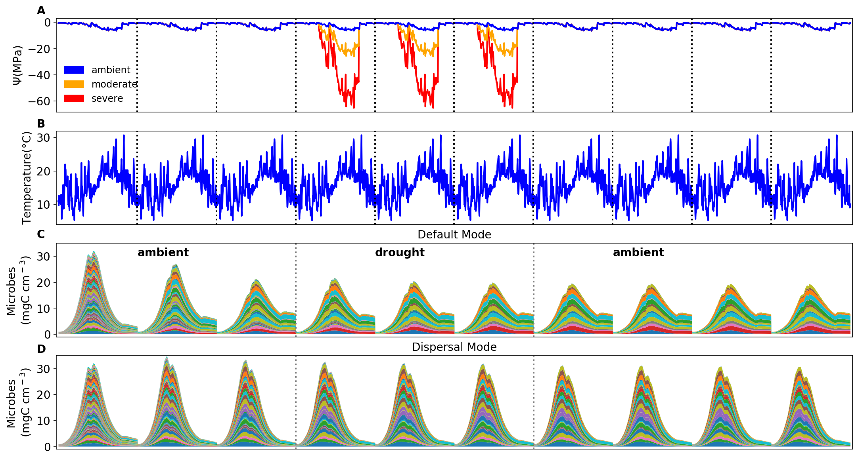

**Supporting Fig. 2 Environmental forcing and microbial community dynamics.** (**A**) Ambient daily water potential of 2011, with the orange and red line denoting the moderate and severe drought scenario, respectively, which are manipulated values simply by multiplying the water potential across the dry season (from April through September) by 4 and 10, respectively. (**B**) The corresponding daily temperature. (**C, D**) Microbial community dynamics of the default vs. dispersal mode over 10 years under the ambient drought scenario.The simulation experiences three phases as separated by the dashed grey lines: a spin-up phase of three years to realize a relatively stable community; a disturbance phase of imposing different drought scenarios for three years; and a final recovery phase after drought disturbance. Colored bands represent different hypothetical taxa.

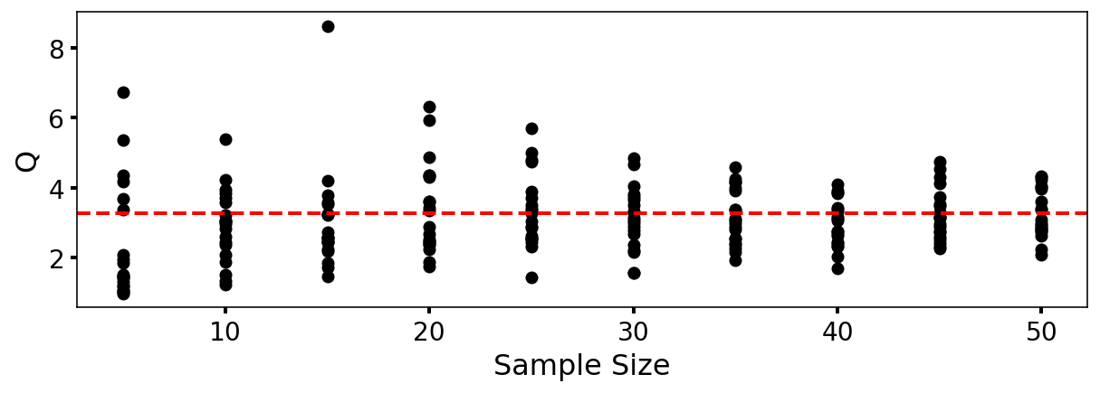

**Supporting Fig. 3** **DEMENTpy (v1.0) stochasticity convergence analysis**. Q (quotient) is calculated as (90% percentile -10% percentile)/median with the data of degradation of substrates following Bugmann et al. (1996). Each sample size has 20 replicates that were randomly drawn from a sample pool of 112 runs. This analysis illustrates that a sample size of 40, which starts displaying relatively stabilized and converged variation, may be an appropriate choice considering a tradeoff of reliability vs. consumption of computing resource.

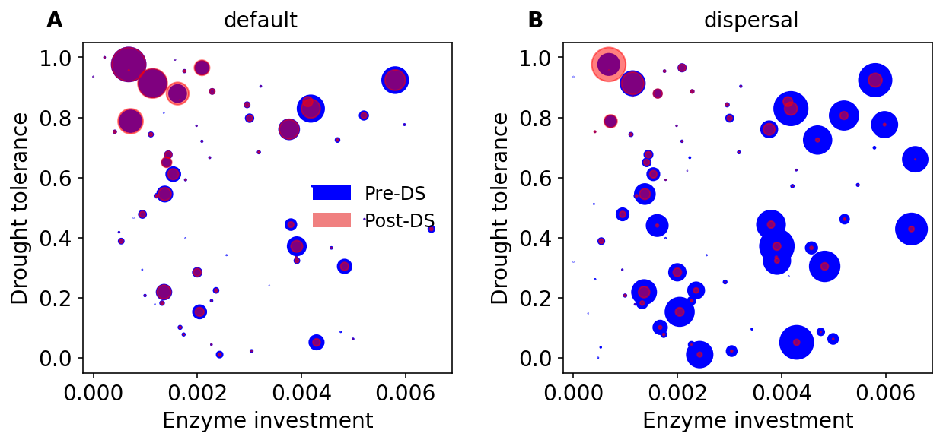

**Supporting Fig. 4 Taxonomic changes in traits across dry season. (A)** Taxon-specific traits of drought tolerance and enzyme investment ofa microbial community without dispersal before (blue) and after the dry season (red) under the ambient scenario. (**B**) The same for a microbial community with dispersal. Each point corresponds to a different taxon, and the size is proportional to its biomass.



**Supporting Fig. 5 Substrate-specific dynamics under differing drought scenarios. (A, B, C)** the dynamics under ambient, moderate, and severe scenarios in default mode for year 3 and year 6 (the 3rd year under drought disturbance) through year 9. (D, E) the same for the dispersal mode but with only ambient and severe scenarios. Each color band represents one type of 12 different substrates.

**Supporting Fig. 6. DEMENTpy programming structure.** DEMENTpy emerges from hierarchically restructuring and mechanistically updating DEMENT programmed in R.